

**Department of Electrical and Computer Engineering**

**North South University**

**Senior Design Project**

**MedEase**

**Blockchain based Electronic Healthcare System**

[**Chowdhury Nafis Faiyaz**](mailto:nafis.faiyaz@northsouth.edu)**, ID- 1931841642**

[**Ayman Ibne Hakim**](mailto:ayman.hakim@northsouth.edu)**, ID- 2103364042**

**Faculty Advisor:**

**Mohammad Ashrafuzzaman Khan**

**Assistant Professor**

**ECE Department**

**Summer, 2023**

# LETTER OF TRANSMITTAL

June, 2023

To

Dr. Rajesh Palit

Chairman,

Department of Electrical and Computer Engineering

North South University, Dhaka

Subject: **Submission of Capstone Project Report on “MedEase Blockchain based Electronic Healthcare System”**

Dear Sir,

With due respect, we would like to submit our **Capstone Project Report** on **“MedEase- Blockchain based Electronic Healthcare System”** as a part of our BSc program. The report deals with a blockchain based electronic health care system. This project was very much valuable to us as it helped us gain experience from practical fields and apply in real life. We tried to the maximum competence to meet all the dimensions required from this report.

We will be highly obliged if you kindly receive this report and provide your valuable judgment. It would be our immense pleasure if you find this report useful and informative to have an apparent perspective on the issue.

Sincerely Yours,

.........................................................

Chowdhury Nafis Faiyaz

ECE Department

North South University, Bangladesh

........................................................

Ayman Ibne Hakim

ECE Department

North South University, Bangladesh

# APPROVAL

Chowdhury Nafis Faiyaz (ID # 1931841642) And Ayman Ibne Hakim (ID # 2103364042) from Electrical and Computer Engineering Department of North South University, have worked on the Senior Design Project titled “**MedEase- Blockchain based Electronic Healthcare System**” under the supervision of Mohammad Ashrafuzzaman Khan partial fulfillment of the requirement for the degree of Bachelors of Science in Engineering and has been accepted as satisfactory.

**Supervisor’s Signature**

…………………………………….

**Mohammad Ashrafuzzaman Khan**

**Assistant Professor**

Department of Electrical and Computer Engineering

North South University

Dhaka, Bangladesh.

**Chairman’s Signature**

…………………………………….

**Dr. Rajesh Palit**

**Professor**

Department of Electrical and Computer Engineering

North South University

Dhaka, Bangladesh.

# DECLARATION

This is to declare that this project is our original work. No part of this work has been submitted elsewhere partially or fully for the award of any other degree or diploma. All project related information will remain confidential and shall not be disclosed without the formal consent of the project supervisor. Relevant previous works presented in this report have been properly acknowledged and cited. The plagiarism policy, as stated by the supervisor, has been maintained.

Students’ names & Signatures

.........................................................

Chowdhury Nafis Faiyaz

ECE Department

North South University, Bangladesh

........................................................

Ayman Ibne Hakim

ECE Department

North South University, Bangladesh

# ACKNOWLEDGEMENTS

The authors would like to express their heartfelt gratitude towards their project and research supervisor, Mohammad Ashrafuzzaman Khan, Assistant Professor, Department of Electrical and Computer Engineering, North South University, Bangladesh, for his invaluable support, precise guidance and advice pertaining to the experiments, research and theoretical studies carried out during the course of the current project and also in the preparation of the current report.

Furthermore, the authors would like to thank the Department of Electrical and Computer Engineering, North South University, Bangladesh for facilitating the research. The authors would also like to thank their loved ones for their countless sacrifices and continual support.

# ABSTRACT

**MedEase**

**Blockchain based Electronic Healthcare System**

The healthcare industry is witnessing a digital transformation with the advent of blockchain technology, offering an innovative approach to managing electronic health records (EHRs) and healthcare data. This abstract presents an overview of the potential benefits, challenges, and implications of implementing a blockchain-based electronic healthcare system.

Blockchain technology's core features, including decentralization, immutability, transparency, and cryptographic security, make it an ideal solution for healthcare data management. This system offers a tamper-proof and secure environment for storing, sharing, and accessing patient information. Healthcare providers, patients, and other authorized stakeholders can access EHRs with reduced concerns about data breaches, unauthorized access, or fraudulent activities.

Moreover, the use of smart contracts within blockchain-based healthcare systems automates various administrative processes, such as consent management, and data sharing agreements. This automation streamlines operations, reduces human error, and enhances overall efficiency in healthcare. However, blockchain-based healthcare systems face certain challenges, including scalability, interoperability, and regulatory compliance. Scalability is crucial as the system must handle a vast amount of healthcare data efficiently. Interoperability is essential to ensure that various healthcare institutions and systems can communicate and share data securely.

In conclusion, a blockchain-based electronic healthcare system has the potential to revolutionize the healthcare industry by improving data security, streamlining operations, and increasing transparency. While challenges remain, addressing scalability, interoperability, and regulatory compliance will be essential to realizing the full potential of blockchain technology in healthcare. The adoption of such systems promises a future where patients and healthcare providers can trust that sensitive medical data is secure, accessible, and efficiently managed, ultimately leading to improved patient care and outcomes.

TABLE OF CONTENTS

LETTER OF TRANSMITTAL 3

APPROVAL 5

DECLARATION 6

ACKNOWLEDGEMENTS 8

ABSTRACT 9

LIST OF FIGURES 13

LIST OF TABLES 14

Chapter 1 Introduction 15

1.1 Background and Motivation 15

1.4 Purpose and Goal of the Project 16

1.5 Organization of the Report 16

Chapter 2 Research Literature Review 17

2.1 Existing Research and Limitations 17

Chapter 3 Methodology 18

3.1 System Design 18

3.1.1 Class Diagram 18

3.1.2 UseCase Diagram 19

3.1.4 Flowchart of blockchain file storage 20

3.2 Hardware and/or Software Components 22

Chapter 4 Investigation/Experiment, Result, Analysis and Discussion 24

Chapter 5 Impacts of the Project 25

5.1 Impact of this project on societal, health, safety, legal and cultural issues 25

5.2 Impact of this project on environment and sustainability 25

Chapter 6 Project Planning and Budget 27

Chapter 7 Complex Engineering Problems and Activities 28

7.1 Complex Engineering Problems (CEP) 28

7.2 Complex Engineering Activities (CEA) 29

Chapter 8 Conclusions 30

8.1 Summary 30

8.2 Limitations 30

8.3 Future Improvement 30

References 31

# LIST OF FIGURES

**LETTER OF TRANSMITTAL 3**

**APPROVAL 5**

**DECLARATION 6**

**ACKNOWLEDGEMENTS 8**

**ABSTRACT 9**

**LIST OF FIGURES 13**

**LIST OF TABLES 14**

**Chapter 1 Introduction 15**

1.1 Background and Motivation 15

1.4 Purpose and Goal of the Project 16

1.5 Organization of the Report 16

**Chapter 2 Research Literature Review 17**

2.1 Existing Research and Limitations 17

**Chapter 3 Methodology 18**

3.1 System Design 18

3.1.1 Class Diagram 18

3.1.2 UseCase Diagram 19

3.1.4 Flowchart of blockchain file storage 20

3.2 Hardware and/or Software Components 22

**Chapter 4 Investigation/Experiment, Result, Analysis and Discussion 24**

**Chapter 5 Impacts of the Project 25**

5.1 Impact of this project on societal, health, safety, legal and cultural issues 25

5.2 Impact of this project on environment and sustainability 25

**Chapter 6 Project Planning and Budget 27**

**Chapter 7 Complex Engineering Problems and Activities 28**

7.1 Complex Engineering Problems (CEP) 28

7.2 Complex Engineering Activities (CEA) 29

**Chapter 8 Conclusions 30**

8.1 Summary 30

8.2 Limitations 30

8.3 Future Improvement 30

**References 31**

# LIST OF TABLES

Table I. List of Software/Hardware Tools 14

Table II. A Sample Complex Engineering Problem Attributes 18

Table III. A Sample Complex Engineering Problem Activities 19

# Chapter 1 Introduction

## Background and Motivation

* 1. Background-

Electronic Health Records (EHRs) have emerged as a pivotal advancement in the healthcare industry, replacing traditional paper-based medical records with digital counterparts. This transformation stems from the need to overcome several longstanding challenges in healthcare management. The paper-based record-keeping systems were notorious for being error-prone, inefficient, and often plagued by issues of accessibility and security. They also failed to facilitate the exchange of medical information between different healthcare providers and stakeholders, hindering continuity of care and patient safety. Our aim with this project is to introduce a system where the users (patients, doctors, administrations) can use our platform to seamlessly deliver a service to the patients. We have focused on securely storing confidential patient data by using a tamper proof, decentralized blockchain system.

* 1. Motivation-

The motivation behind Electronic Health Records (EHRs) lies in addressing critical challenges within the healthcare industry. EHR adoption is driven by the need to:

1. Enhance Patient Care: EHRs improve access to vital patient information, enabling more informed clinical decisions and reducing medical errors, ultimately leading to better patient care.
2. Streamline Care Coordination: EHRs facilitate seamless communication among healthcare providers, ensuring consistent and coordinated care for patients, especially in complex medical cases.
3. Ensure Data Security: EHRs offer robust security measures, safeguarding patient data and reducing vulnerabilities to breaches, a pressing concern in healthcare.
4. Boost Efficiency: Automation of administrative tasks, such as billing and appointment scheduling, increases operational efficiency, reducing errors and cutting costs.
5. Contribute to Research: EHRs enable data sharing for medical research and public health efforts, fostering medical advancements and informed healthcare policies.
6. Regulatory Compliance: Compliance with healthcare regulations and standards is a driving force, as non-compliance can result in penalties and loss of accreditation.
7. Engage Patients: EHRs empower patients to take a more active role in their healthcare, fostering patient-centered approaches and shared decision-making.

In summary, EHR adoption aims to revolutionize healthcare by improving care quality, security, efficiency, research contributions, and patient engagement. It represents a fundamental shift towards a more effective and patient-centric healthcare ecosystem

## Purpose and Goal of the Project

[Describe the objective of the project. Students can write the contributions of the project and explicitly mention their novelty.]

## Organization of the Report

[Describe the arrangement of different sections of the report. For example, Chapter 2 presents the literature reviews related to this project.]

# Chapter 2 Research Literature Review

## 2.1 Existing Research and Limitations

[Briefly discuss some of the recent articles related to this research. For example, “Valverde et al. [2] developed a transfer learning-based CNN model for automatic glaucoma classification. The authors used color fundus images from DRISHTI-GS and RIM-ONE datasets. They preprocessed the images and applied five CNN models with transfer learning techniques. Among these, the VGG-19 model showed the best result with an AUC of 94% with a sensitivity and specificity score of 87.01% and 89.01%, respectively.”]

[Discuss the research limitations in the existing articles. For example, “The following observations have been made after a detailed examination of the literature reviews − (i) most of the articles employed an individual open-source or custom Bangla sign language dataset of small size, (ii) in general, the articles did not utilize multiple deep learning techniques and compared their performances, and (iii) there is an absence of deploying the sign language detection into an embedded device for real-time analysis. These investigations have motivated us to implement a Bangla sign language detection system in this paper using combined open-source and custom datasets and apply three deep learning approaches (Detectron2, EfficientDet-D0, and YOLOv7). Finally, the YOLOv7 Tiny has been implemented in a Jetson Nano edge device for real-time Bangla sign language recognition.”]

# Chapter 3 Methodology

## 3.1 System Design

### **3.1.1 Class Diagram**

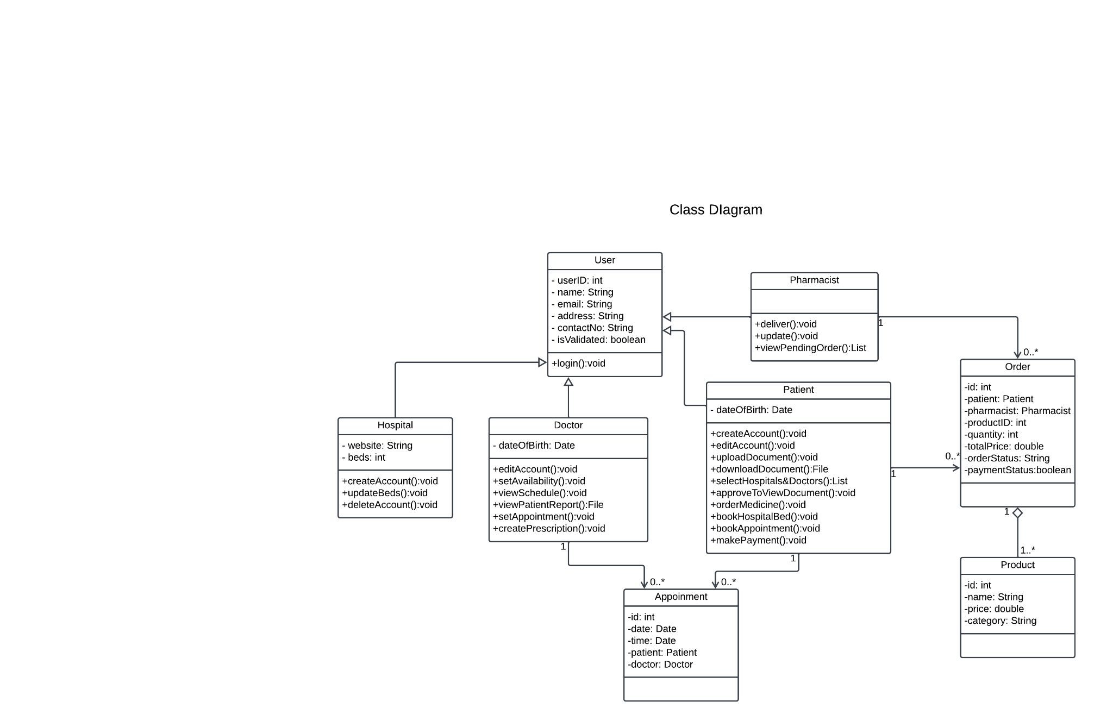

### **3.1.2 UseCase Diagram**

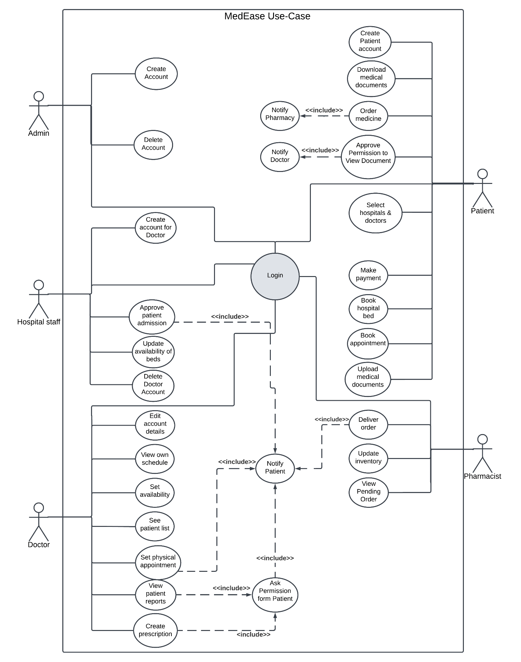

### **3.1.4 Flowchart of blockchain file storage**

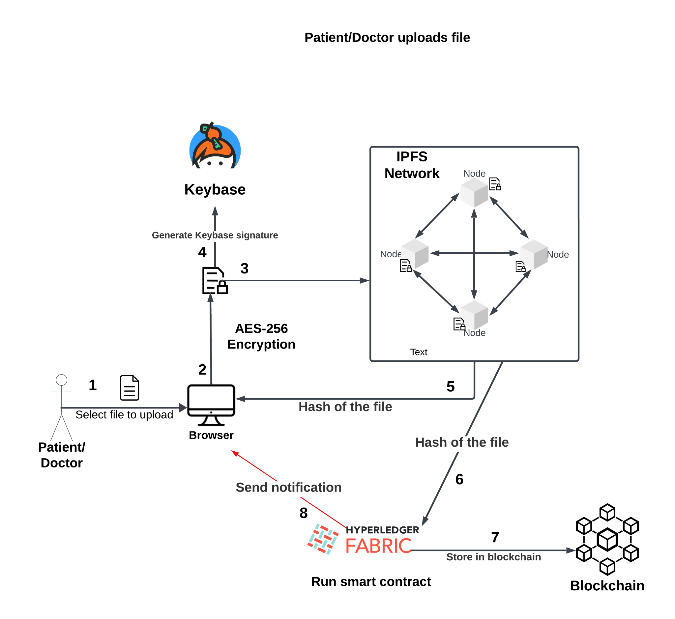

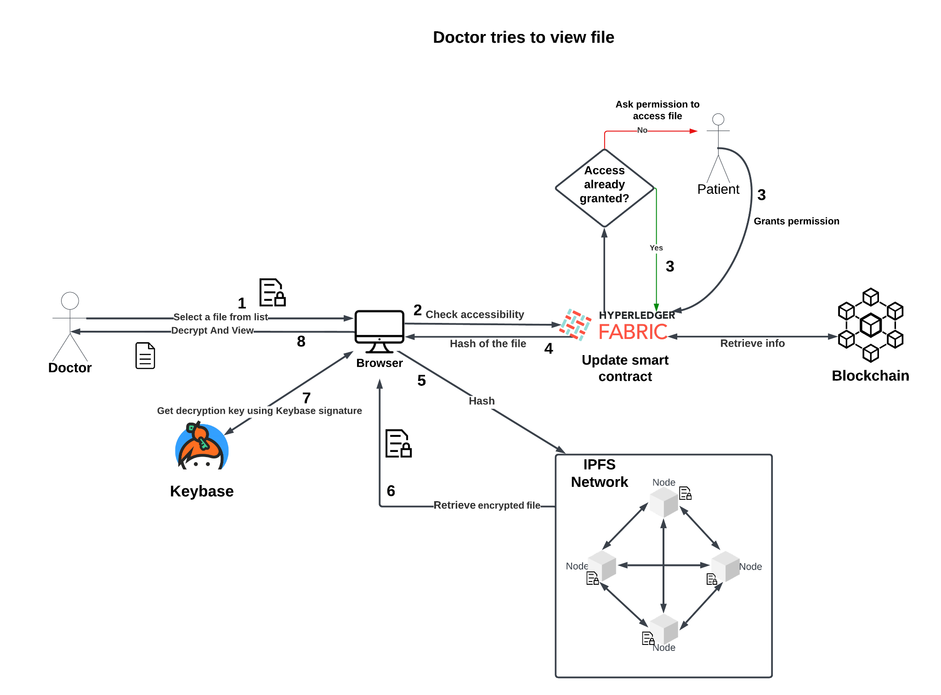

## 

## 3.2 Hardware and/or Software Components

The software component of this healthcare system, developed with a technology stack comprising React, Next.js, Tailwind CSS, Node.js, and blockchain, plays a pivotal role in revolutionizing patient data and medical report management. React and Next.js, together with Tailwind CSS, provide a robust and responsive user interface, offering a seamless and intuitive user experience for healthcare professionals and patients alike. Node.js powers the backend, ensuring efficient data processing and management. However, the most innovative aspect of this system lies in its utilization of blockchain technology for storing patient data and reports.

Blockchain provides a secure, transparent, and tamper-proof environment for sensitive medical information. Patient records and reports are encrypted and stored on the blockchain, ensuring that only authorized users can access them, thereby enhancing data security and privacy. Immutability and cryptographic mechanisms guarantee the integrity of the stored data, making it resistant to unauthorized alterations or breaches. The use of smart contracts streamlines administrative processes, such as consent management and data sharing agreements, further enhancing operational efficiency.

This software component represents a cutting-edge solution in healthcare data management, offering the combined benefits of a user-friendly interface, efficient data processing, and the unparalleled security and transparency of blockchain technology. It ultimately contributes to better patient care, streamlined operations, and a trustworthy and efficient healthcare ecosystem.

Table I. List of Software/Hardware Tools

| **Tool** | **Functions** | **Other similar Tools (if any)** | **Why selected this tool** |
| --- | --- | --- | --- |
| **React and tailwind css** | **Front end development** |  |  |
| **Node.js** | **Backend development** |  |  |
| **Blockchain** | **Storing patient Data** |  |  |

# Chapter 4 Investigation/Experiment, Result, Analysis and Discussion

[Describe the experiments performed addressing all the variables, various results of the project with appropriate figures, tables and texts. The tables and figures should contain appropriate brief captions. Figures should contain appropriate axis labels and legends. The tables and figures should be cited in the project. Perform in-depth analyses of the results represented by each of the figures and tables and finally perform a constructive discussion on the outcome.]

# Chapter 5 Impacts of the Project

## 5.1 Impact of this project on societal, health, safety, legal and cultural issues

The adoption of electronic medical records (EMRs) has multifaceted social effects. Firstly, EMRs significantly enhance patient care by facilitating quick and accurate access to medical information, resulting in faster diagnoses, reduced errors, and improved treatment outcomes, thereby elevating overall healthcare quality. Moreover, they streamline administrative tasks, such as appointment scheduling and billing, increasing operational efficiency, reducing wait times, and allowing healthcare professionals to prioritize patient care. However, the digital nature of EMRs raises valid concerns about data security and patient privacy, necessitating robust cybersecurity measures and regulatory compliance to safeguard sensitive information. Nevertheless, the widespread adoption of EMRs may inadvertently exacerbate healthcare access disparities, as individuals lacking internet access or digital literacy skills encounter barriers to using these systems. This calls for healthcare organizations to provide alternative solutions for underserved populations. Additionally, healthcare professionals must adapt to EMRs, potentially requiring training and adjustment to new workflows, with the transition impacting job satisfaction and work-life balance for some. Lastly, ethical considerations arise regarding data ownership, consent, and the potential misuse of patient information. Healthcare providers must adhere to ethical guidelines and transparent data practices to maintain trust with patients.

## 5.2 Impact of this project on environment and sustainability

The adoption and utilization of electronic medical record (EMR) healthcare web applications have discernible environmental effects. Chief among these is the significant reduction in paper usage, mitigating the environmental impact associated with the extensive use of paper in traditional medical records, which leads to deforestation and heightened energy consumption for printing and storage. Furthermore, EMRs necessitate data centers and servers for the storage and management of patient data, which consume energy for their operation and cooling. Nonetheless, when compared to the energy-intensive maintenance of paper records, EMRs tend to have a lower overall environmental impact, particularly when data centers employ renewable energy sources. Nevertheless, the continual upgrading and replacement of hardware and software components in EMRs contribute to electronic waste (e-waste), underlining the importance of proper disposal and recycling of outdated equipment like hardware, batteries, and electronic chips to mitigate this environmental concern. Additionally, the carbon emissions from data centers hosting healthcare web applications are contingent on factors such as their energy efficiency and the source of their electricity.

# Chapter 6 Project Planning and Budget

Proposed execution timeline for MedEase

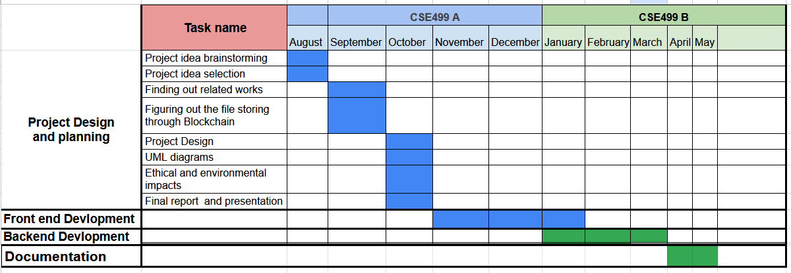

Figure 1. A sample Gantt chart.

[Describe the budget of the project with approximate cost of individual components and the entire design. A sample budget of the project is given below.]

Figure 2. A sample budget table.

# Chapter 7 Complex Engineering Problems and Activities

## 7.1 Complex Engineering Problems (CEP)

[Describe the Complex Engineering Problems (CEP) attributes related to this project. Discuss with your capstone project supervisor regarding the table. A sample table is given below.]

Table II. A Sample Complex Engineering Problem Attributes

| **Attributes** | | **Addressing the complex engineering problems (P) in the project** |
| --- | --- | --- |
| P1 | Depth of knowledge required (K3-K8) | The project requires knowledge of Electrical Circuits, Electronics (K3), Wireless Communication, Embedded System, Sensors and Instrumentations (K4), Designing and Simulation (K5), Engineering & IT (Circuit Design/Smartphone Application) Tools (K6), Involve Environmental Effects (K7), Scientific Research Papers (WK8). |
| P2 | Range of conflicting requirements | In the prototype, the strength of the structure (mass) and capability of weightlifting (# of sensors) is directly related to the capacity of the motors. |
| P3 | Depth of analysis required | No unique way to design. Depth of analysis needed to select a specific solution from many alternatives. (Static/mobile/drone. Various microcontrollers. Various sensors) |
| P4 | Familiarity of issues | Various air quality sensors, Raspberry Pi/Arduino Mega/Nano/Uno/NodeMCU Microcontroller. |
| P5 | Extent of applicable codes | There is no existing code or standard for this project. |
| P6 | Extent of stakeholder involvement | There are several stakeholders needs to be involved including the owner of the device, installing places, Ministry of Environment, etc. |
| P7 | Interdependence | Project involves a number of interdependent sub-systems such as microcontrollers, sensors, wireless communication system, circuit designing tools, mobile apps. |

Table I demonstrates a sample complex engineering problem attribute.

## 

## 7.2 Complex Engineering Activities (CEA)

[Describe the Complex Engineering Activities (CEA) related to this project. Discuss with your capstone project supervisor regarding the table. A sample table is given below.]

Table III. A Sample Complex Engineering Problem Activities

| **Attributes** | | **Addressing the complex engineering activities (A) in the project** |
| --- | --- | --- |
| A1 | Range of resources | This project involves human resource, money, modern tools (simulation software/mobile APP), hardware components, etc. |
| A2 | Level of interactions | Involves interactions between different stakeholders including group members to design the device, installing places, Ministry of Environment to collect data, etc. |
| A3 | Innovation | Employs innovative skills of engineering by introducing technology in a different manner in the environment and IoT sector |
| A4 | Consequences to society  / Environment | Impact in our environment since it helps to monitors the air quality data and measure AQI |
| A5 | Familiarity | Needs to be familiar with the various sensors, microcontrollers, wireless communication system, circuit designing tools, mobile apps. UN SDG #04: Quality education; UN SDG #10: Reduce inequality |

# Chapter 8 Conclusions

## 8.1 Summary

[Describe a short summary of the project.]

## 8.2 Limitations

[Describe the limitations of the project.]

## 8.3 Future Improvement

[Describe the possible future improvements of the project.]

# References

.